***Assignment 7***



Name:

FCU ID:

Team number:

**Topic of this class: Modeling**

Modeling is a representation of a real object or system of objects for purposes of visualizing its appearance or analyzing the behavior by creative application of physical and mathematical sciences to analyze, design, manufacture and utilize products which benefit people. It is a solution of practical engineering analysis and design problems.

There are some advantages about modeling, including:

* Accelerate process and testing
* Minimize technology risk
* Integrate research and design experiment
* Reduce cost and time
* Improve product quality

Recently, there are many computer software using physics-based computational models and simulations applied in different engineering fields, including three main categories as Computer-Aided Design (CAD), Computer-Aided Engineering (CAE) & Computer-Aided Manufacturing (CAM).

|  |
| --- |
| **Learning objectives:**  *New abilities:*   * **ET06:** To collect trustworthy information, literature or data from internet. * **ET07:** Use tools or using modeling package to test or simulate the engineering design. For example: MS Excel, CAD software. * **PS01:** Explain the problem based on synthesis of client, user, and other stakeholder needs. * **PS02:** Justify why problem is important to solve by making reference to relevant global, societal, economic, or environmental issues. * **PS03:** Explain key specifications (in terms of criteria and constraints) that address what the client wants and what the user needs. * **ED01:** Define the problem, criteria, constraints, and requirements. * **IF01:** Generate a wide range of solutions including ideas not readily obvious or combinations of ideas in new ways. Explicitly use and document two or more ideation strategies (biomimicry, brainstorming, exploration of prior art, etc.) to generate ideas. * **IF02:** Generate testable prototypes (physical, visual or conceptual) for a set of potential solutions.   *Review what you learn before:*   * **DA01:** Describe, with calculations, the central tendency of data using descriptive statistics (mean, median, and mode). * **DA02:** Describe, with calculations, variability of data using statistical methods (standard deviation, variance). * **DA03:** Make accurate comparisons across groups with explicit reference to data. * **DA04:** Given independent and dependent variables, interpret or predict the performance of a solution. * **DA05:** Given two variables, describe the relationship and/or calculate the strength of the correlation between these variables. * **DA06:** Interpret the distribution of data in a graph * **UC03:** Define systems or processes with mathematical models with simulation results. * **UC04:** Calculate efficiency of a system, product, or process as it relates to cost, energy, or other engineering factors. * **IL01:** Ask questions to determine what new information is needed to scope and solve a problem. * **IL02:** Include citations within the text (in-text citations) that show how the references at the end of the text are used as evidence to support decisions. * **SQ01:** Use accurate, scientific, mathematical, and/or technical concepts, units, and/or data in solutions. * **SQ02:** Justify design solution based on how well it meets criteria and constraints.   ***You will be graded on completion of the above objectives!*** |

**Engineering modeling project 1:**

**“London bridge is falling down”**

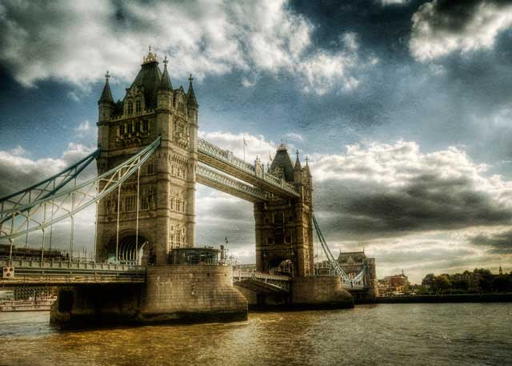

Retrieved from(<http://picssr.com/photos/30297001@N02/favorites/page2>) by jetbluestone

Each team is going to design and build up a wooden bridge for this project. There will have a loading test at the end of next class. The team with maximum loaded will be the winner! The designed bridge should be: (a) made only by prepared woods and adhesive, (b) required size (wide: 5cm; length: 50cm), (c) finished before the time.

This is the first engineering modelling exercise for you and your team in this course. Before you build up your wooden bridge, there are some preparation required. Please answer the following questions carefully with your teammates. These will be very helpful for your design.

1. **Team activity: What required for a modeling?**
   1. Discuss with you team ant write done the information required for engineering modelling.

**Answer columns:**

|  |
| --- |
| * 1. **What required for an modeling** |
|  |

* 1. Problem scoping practice – answer the following questions:

1. Who is the client?
2. What is the client’s problem that needs a solution?
3. Why is the problem important to solve?
4. Who are the end users?
5. What will make your solution effective (criteria)?
6. What are limitations (constraints)?

**Answer columns:**

|  |
| --- |
| 1. **Who is the client?** |
|  |
| 1. **What is the client’s problem that needs a solution?** |
|  |
| 1. **Why is the problem important to solve?** |
|  |
| 1. **Who are the end users?** |
|  |
| 1. **What will make your solution effective (criteria)?** |
|  |
| 1. **What will limit how you can solve the problem (constraints)?** |
|  |

* 1. Problem statement – a good problem statement should include:

1. Explains the problem based on synthesis of client, user and other stakeholder needs.
2. Explains the key specifications (in terms of criteria and constraints) that address what the client wants and what the user needs.

**Answer columns:**

|  |
| --- |
| * 1. **Problem statement** |
|  |

* 1. Ask questions to gather the information you will need to solve the problem.

1. What has already been done to solve the problem (products fill a similar need)?
2. How will our procedure be tested?
3. How should we measure success?
4. What kind of background knowledge is required to solve the problem?

**Answer columns:**

|  |
| --- |
| **Your question 1** |
| **Question:**  **Answer:** |
| **Your question 2** |
| **Question:**  **Answer:** |

1. **Team activity: Build up the bridge.**

2-1 Design several blueprints for your bridge:

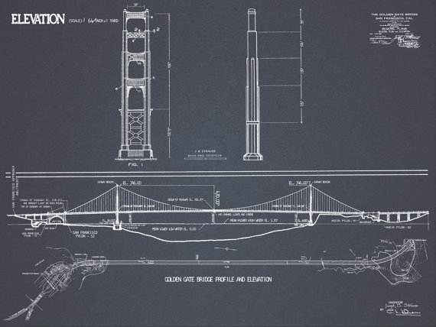

**Answer columns:**

|  |  |  |
| --- | --- | --- |
| **Design 1.** | | |
|  | **Pros.** | |
|  | |
| **Cons.** | |
|  | |
| **Design 2.** | | |
|  | | **Pros.** |
|  |
| **Cons.** |
|  |

2-2 Build up your final decision (bridge):

|  |
| --- |
| **Memo of your design** |
|  |

1. **Individual contributions**

Individually, each team member should describe his/her contributions to these activities.

|  |  |
| --- | --- |
| **Team member name** | **Team members’ contribution to the team activities above** |
|  |  |
|  |  |
|  |  |
|  |  |